# An Introduction to computer vision

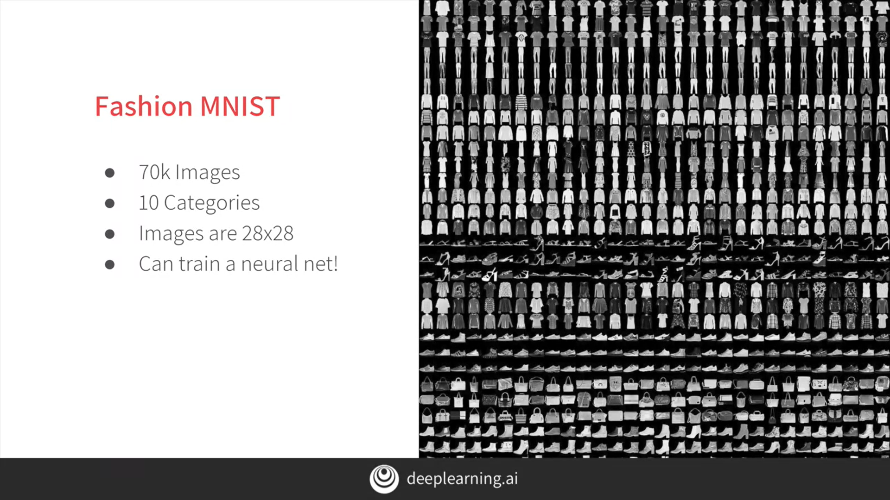

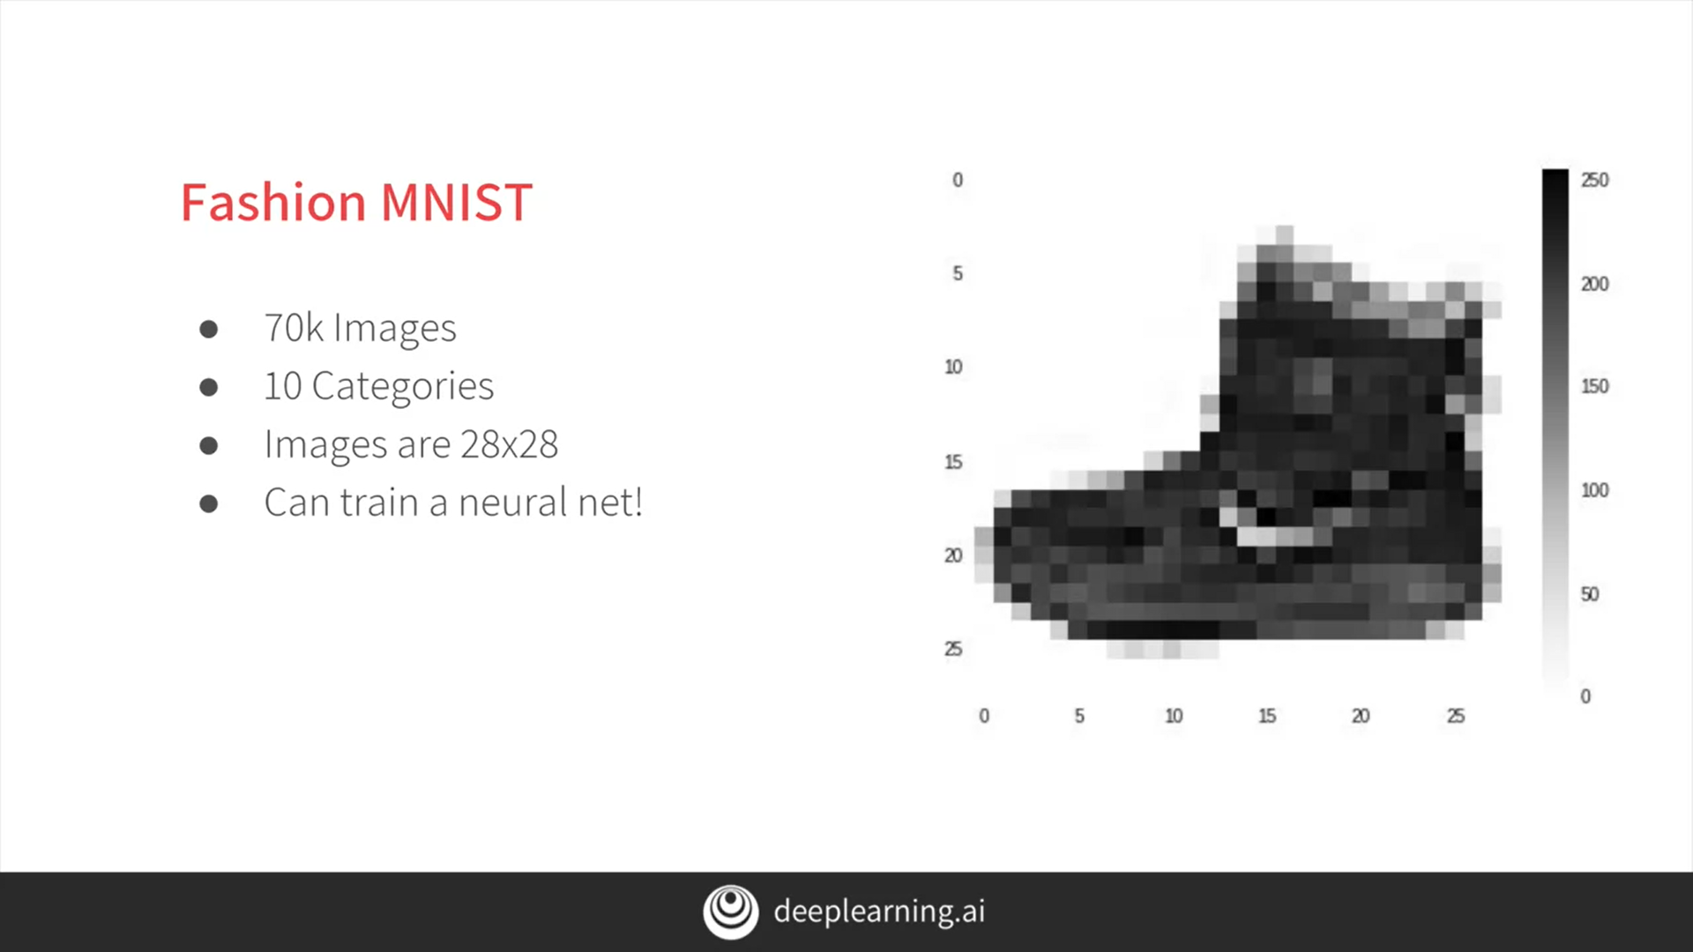

# Writing code to load training data

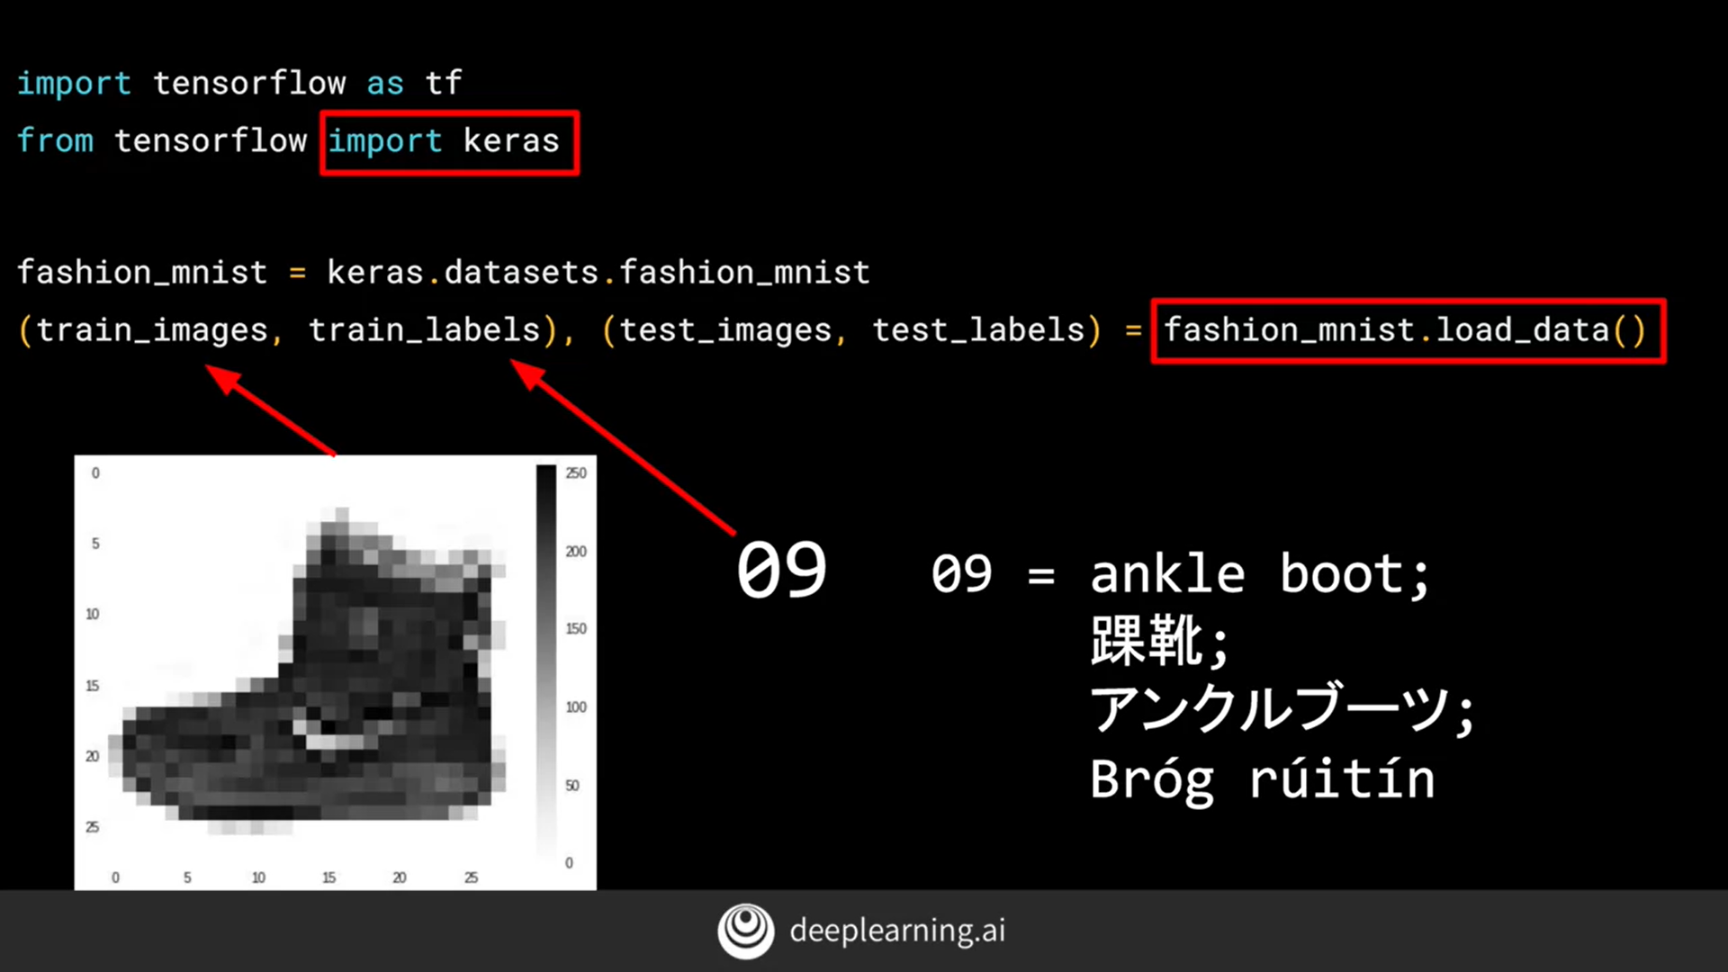

# Coding a Computer Vision Neural Network

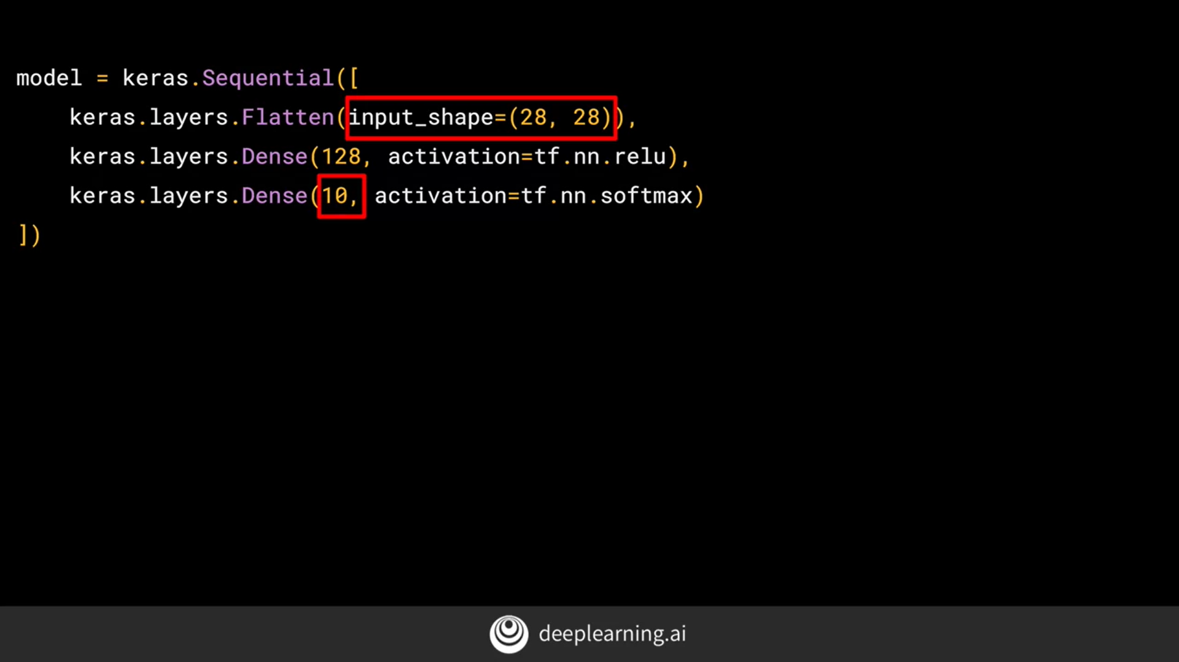

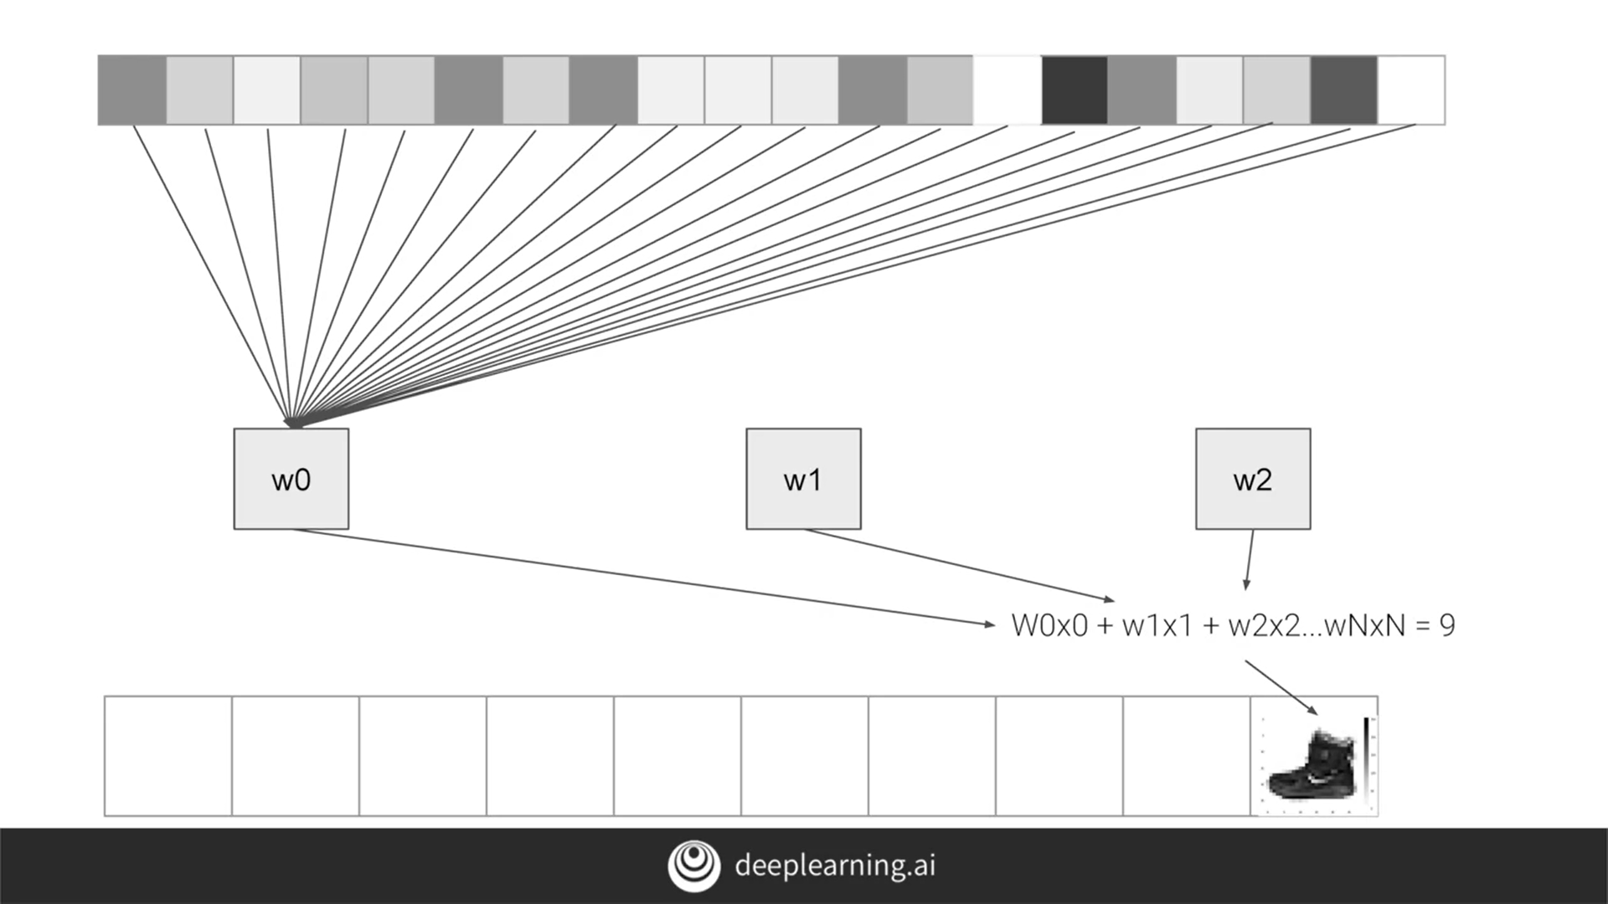

# Walk through a Notebook for computer vision

<https://colab.research.google.com/drive/1CtkhQyU0sdeMOSAbXk6Odai4ADHokDQv>

# Using Callbacks to control training

Before -

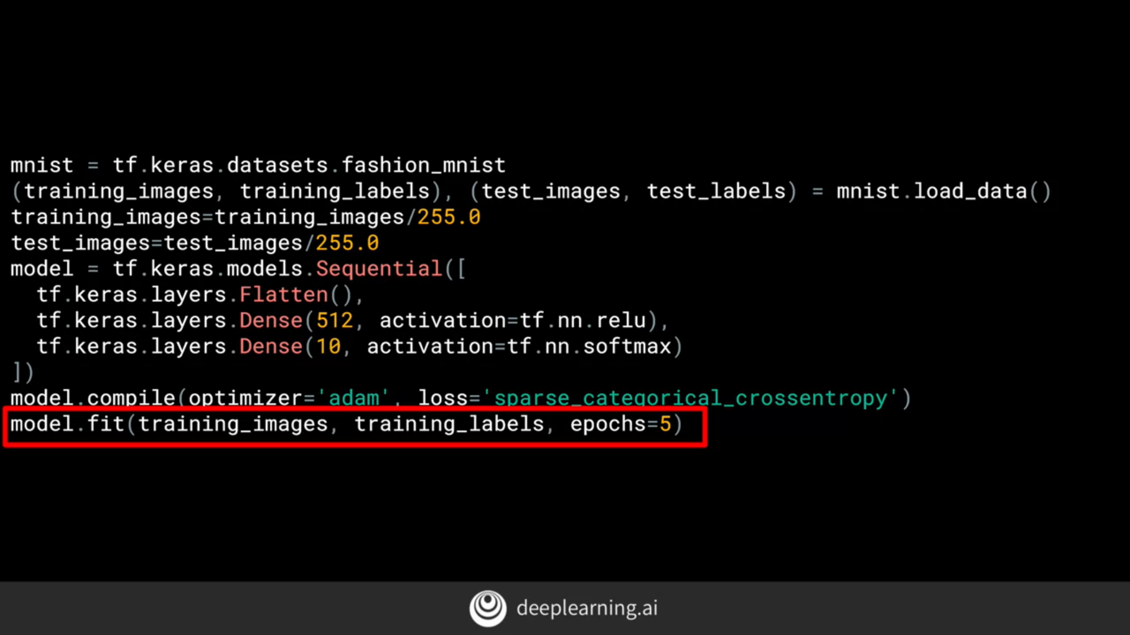

After-

